**Tutorial 1**

1)

public class Hello{

public static void main(String args[]){

System.out.println("Hello World");

}

}



2)

public class Name{

public static void main (String args[]){

System.out.println("Dinuka Piyadigama");

}

}



3)

import java.util.Scanner;

public class Height{

public static void main (String args[]){

Scanner sc = new Scanner(System.in);

System.out.println("Enter your Height in meteres:");

int height = sc.nextInt();

System.out.println("Your height is "+height+"m");

}

}

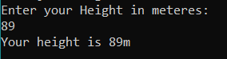

4)

import java.util.Scanner;

public class FavColor{

public static void main (String args[]){

Scanner in = new Scanner(System.in);

System.out.println("Enter your favourite color:");

String color = in.nextLine();

System.out.println("Your favourite colour is "+color);

}

}

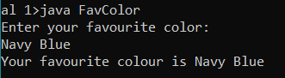

5)

All 3 are incorrect as variables haven’t been initialized.

A variable should start with a simple letter (lowerCamelCase) in Java.

2nd - Variables are assigned. Not compared. An equality operator shouldn’t be used.

3rd – Spaces and special characters aren’t allowed to be used as names of variables.

6)

a] 12

b] 4

c] 2

d] 6

e] 1

public class Results{

public static void main (String args[]){

int result = 0;

int x = 4;

int y = 8;

int z = 2;

int w = 5;

result = x + y;

System.out.println("a] "+result);

result = z * 2;

System.out.println("b] "+result);

result = y / x;

System.out.println("c] "+result);

result = y - z;

System.out.println("d] "+result);

result = w % z;

System.out.println("e] "+result);

}

}

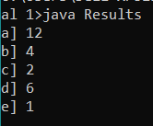

7)

public class Sumation{

public static void main (String args[]){

int total = 10 + 14;

System.out.println("The total of 10 + 14 = "+total);

}

}



8)

public class DueMoney{

public static void main (String args[]){

int down_payment = 20;

int total = 100;

int due = total - down_payment;

System.out.println(due);

}

}



9)

public class Multiplication{

public static void main(String args[]){

int subTotal = 100;

double total = subTotal * 0.15;

System.out.println(total);

}

}



10)

public class Question10{

public static void main(String args[]){

int a = 5;

int b = 2;

int c = 3;

int result = a + b * c;

System.out.println(result);

}

}



11)

public class Question11{

public static void main (String args[]){

int a = 20;

int b = 40;

int c = 30;

(x,y,z) = (a,b,c);

System.out.print(x,y,z);

}

}

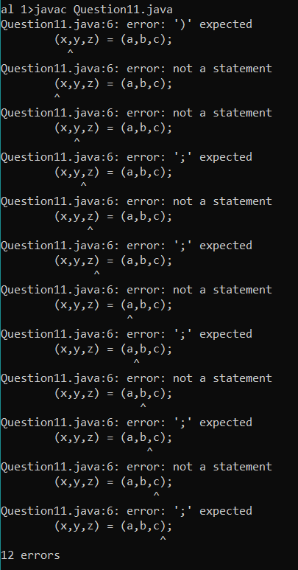

12)

public class Rounding{

public static void main (String args[]){

double sales = 32.34642;

sales = Math.round(sales*100)/ 100.0;

System.out.println(sales);

}

}



13)

Ref: <http://www.java2s.com/Tutorial/Java/0120__Development/Usingthecommaflagtodisplaynumberswiththousandsseparator.htm>